Week – 12 Practical
- Implement the Producer-Consumer problem using counting semaphores and POSIX threads. Evaluate synchronization correctness and system throughput under different buffer sizes.
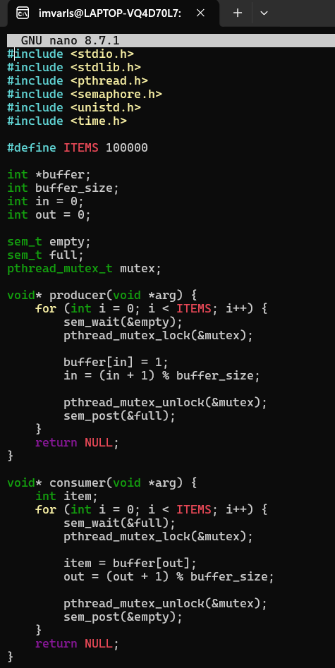

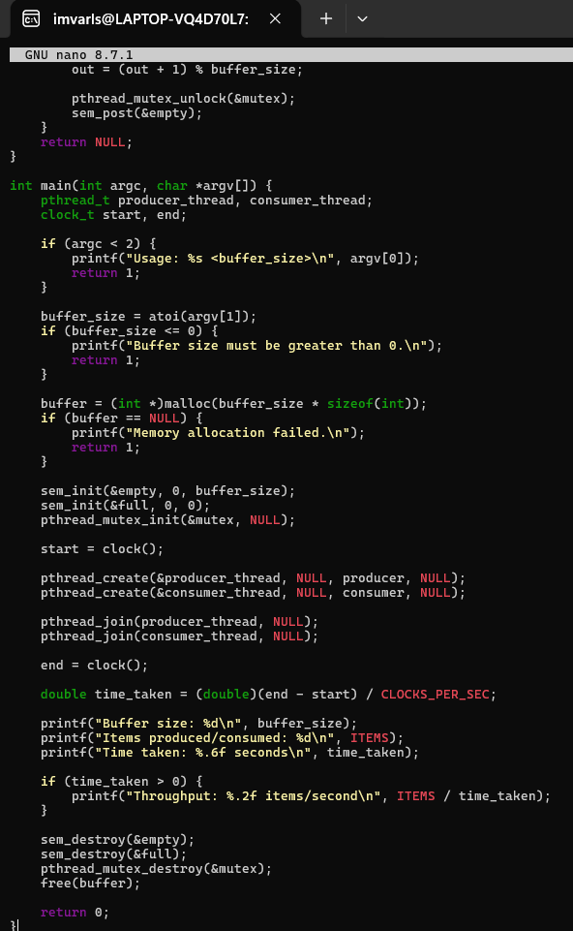

Output:

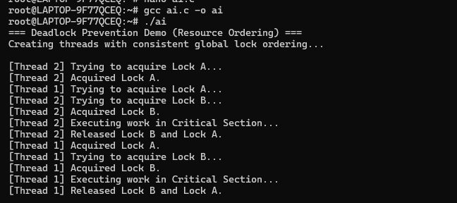
- Design a deadlock scenario involving multiple threads competing for shared resources. Demonstrate deadlock occurrence, identify the four necessary conditions for deadlock, and implement a deadlock prevention strategy using resource ordering.
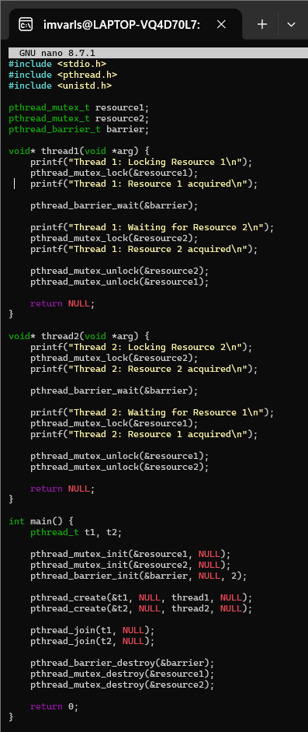
Output:

